Name: Jay Rajesh Umap

Roll No.: 2205010

Enrollment No.: MITU20BTIT0029

Class: LY IT Core

Lab Assignment No.: 4. Hosting using Google App engine

Google App Engine (GAE):

* Service Focus: GAE is a Platform as a Service (PaaS) offering designed to simplify application deployment and management.
* Ease of Use: It abstracts infrastructure complexities, allowing developers to focus on writing code and applications rather than managing servers and resources.
* Scalability: GAE automatically scales applications to handle traffic fluctuations, making it ideal for web applications and APIs.
* Configuration: While it offers less control over infrastructure details compared to Infrastructure as a Service (IaaS), it provides a hassle-free development experience.
* Pricing: GAE offers straightforward pricing based on resources consumed, with predictable costs.

Google Cloud:

* Service Range: Google Cloud Platform (GCP) provides a comprehensive suite of cloud services, including IaaS, PaaS, and SaaS solutions, catering to diverse business needs.
* Use Cases: GCP is suitable for a wide array of applications, from web hosting and data storage to machine learning and big data analytics.
* Control: GCP offers greater control and flexibility, allowing users to configure and manage infrastructure, virtual machines, and various cloud resources.
* Scalability: GCP provides fine-grained control over resource scaling, making it suitable for complex, high-performance workloads.
* Pricing: GCP offers various pricing models for different services, enabling users to optimize costs based on their specific requirements.

Steps:

1. Download and install google cloud cli on your machine (<https://cloud.google.com/sdk/docs/install>)

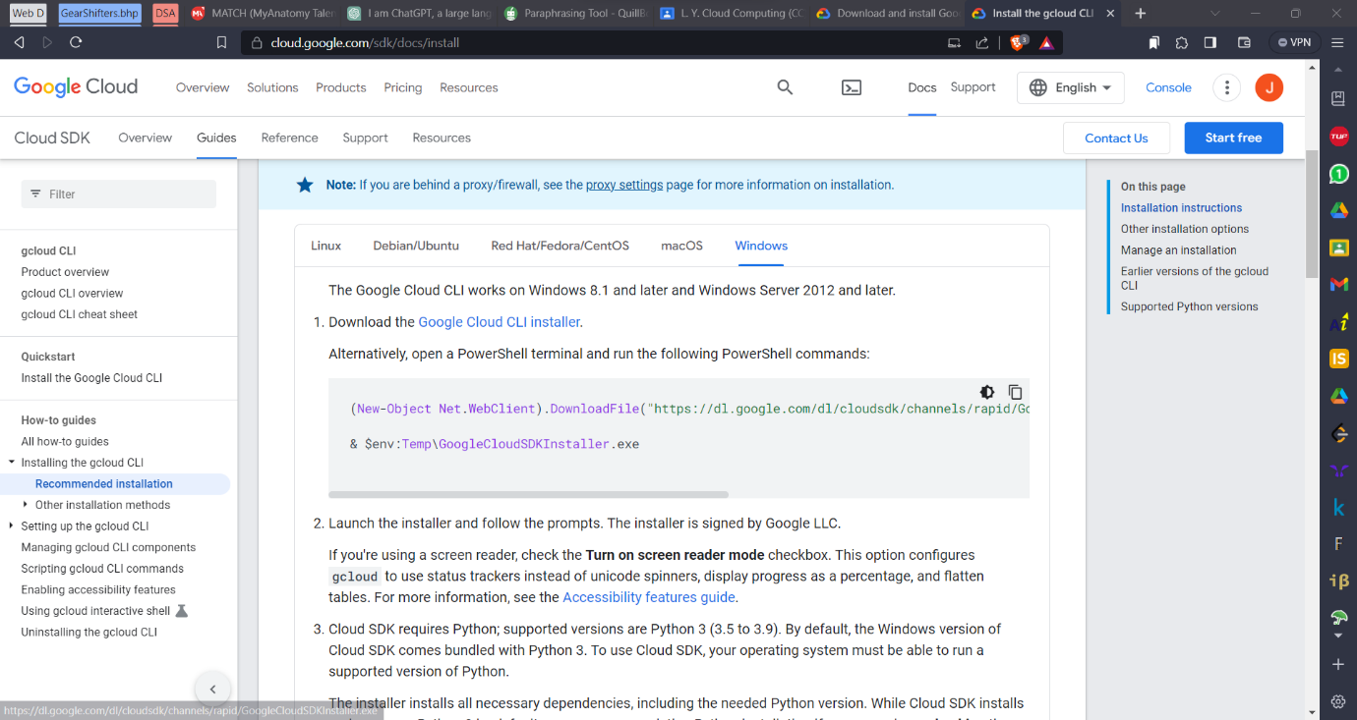

1. Complete the setup as directed via cloud setup wizard

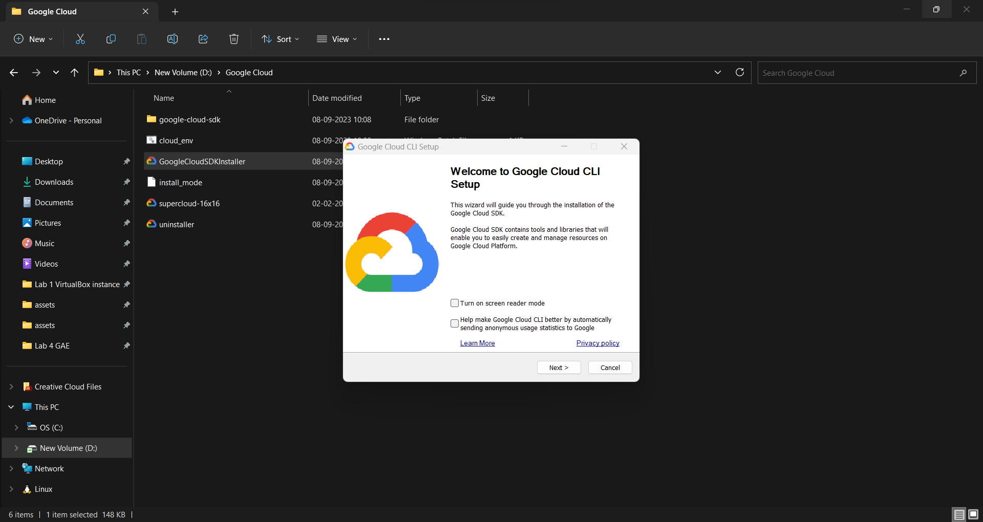

1. Launch Google cloud shell

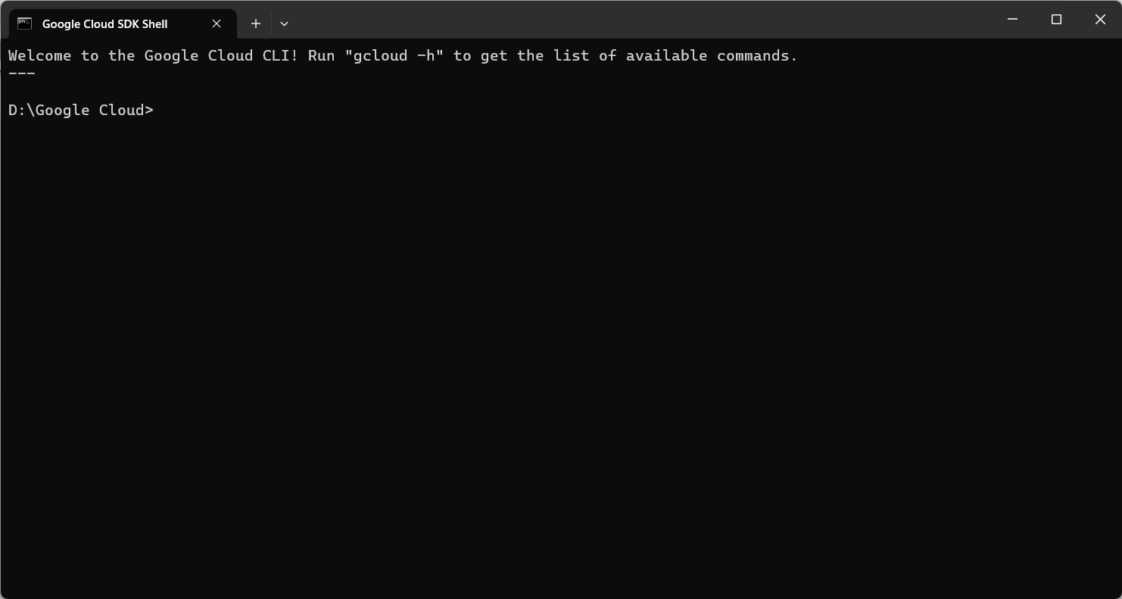

1. Create new directory and create two files inside it app.py and app.yaml

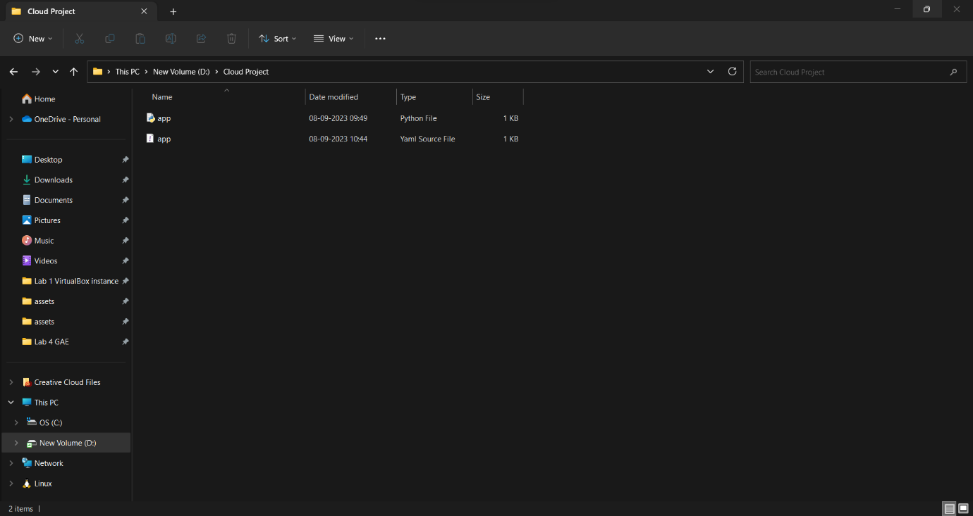

1. app.py and and app.yaml files contains following contents in it

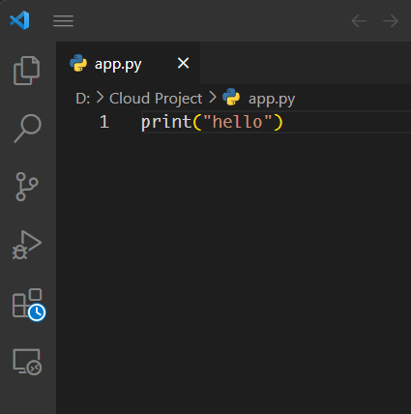

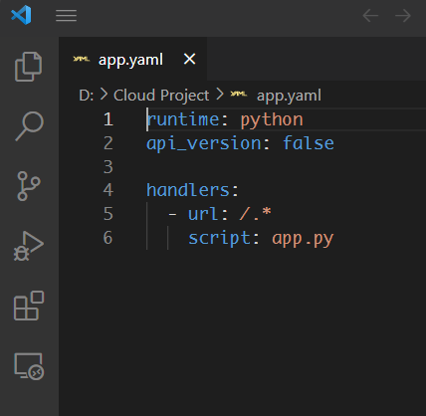

1. Open google cloud and launch this host this python file on localhost using google app engine

Set following path on the cloud shell terminal

google-cloud-sdk\bin\dev_appserver.py

and then type the location of folder name where we have our app.py and app.yaml file

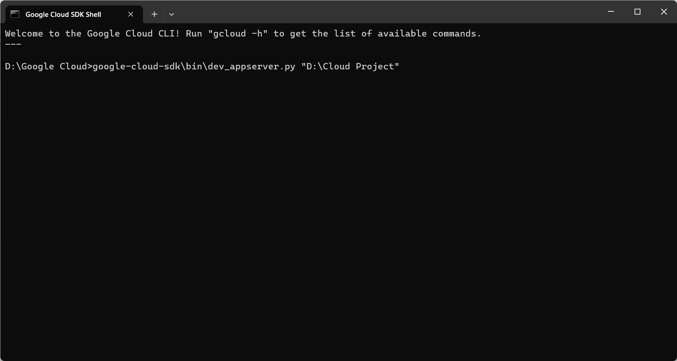

Hit enter after entering folder location

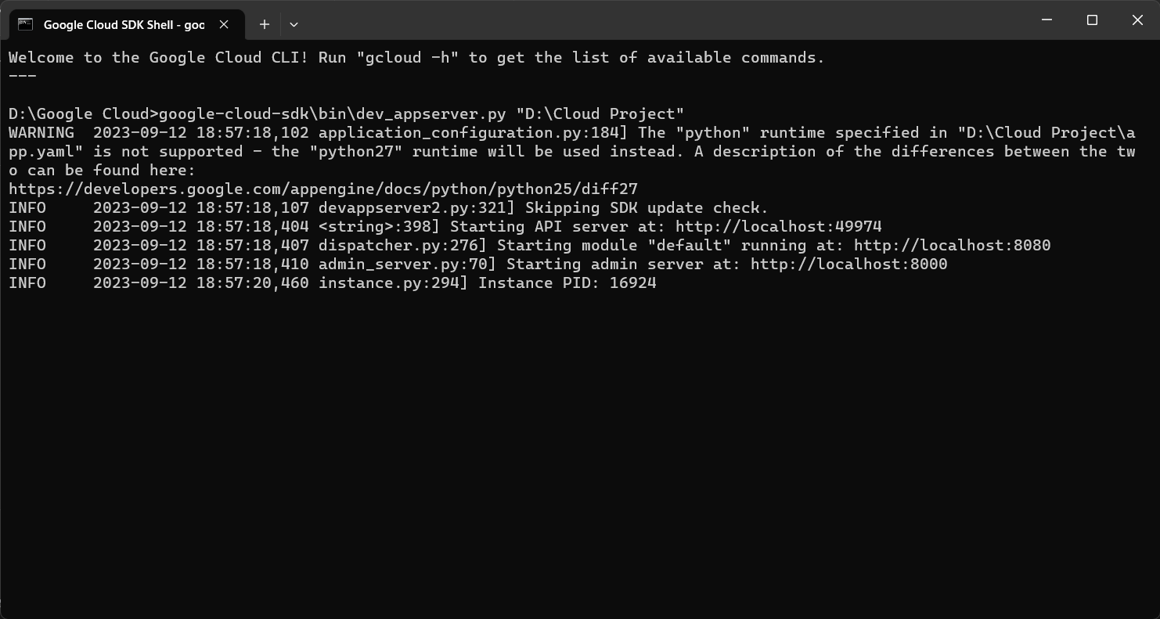

Our site has started running on localhost:8080 as mentioned in the console

Output:

